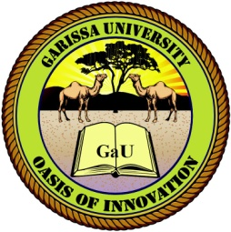
GARISSA UNIVERSITY

UNIVERSITY EXAMINATION 2022/2023 ACADEMIC YEAR ONE
FIRST SEMESTER EXAMINATION

SCHOOL OF EDUCATION, ARTS AND SOCIAL SCIENCES

FOR THE DEGREE OF MASTERS OF EDUCATION IN EDUCATION ADMINISTRATION/CURRICULUM STUDIES

COURSE CODE: EMP 8123

COURSE TITLE: LEADERSHIP IN EDUCATION ( 15 copies)

EXAMINATION DURATION: 3 HOURS

DATE: 26/08/23 TIME: 09.00-12.00 PM

INSTRUCTION TO CANDIDATES

- The examination has FIVE (5) questions
- Question ONE (1) is COMPULSORY
- Choose any other TWO (2) questions from the remaining FOUR (4) questions
- Use sketch diagrams to illustrate your answer whenever necessary
- Do not carry mobile phones or any other written materials in examination room
- Do not write on this paper

This paper consists of TWO (2) printed pages please turn over

QUESTION ONE (COMPULSORY)
- Explain the differences between corporate governance and leadership 8 marks
- Discuss five main elements of transformational leadership 8 marks
- Discuss how you would improve performance as a leader 4 marks

QUESTION TWO
- Discuss five Principles of Leadership 10marks
- Discuss five features of a servant leader leader 5 marks

QUESTION THREE
- With the periscope example, your friend asked you to advise him on the best-emerging leadership theory to use in managing his father ‘s business, what will you advise him and why 10marks
- Explain five standards of an exceptional leader 5 marks

QUESTION FOUR
- Abdi and Ali once argued that the democratic leadership style is the best approach and is better than autocratic. Do you agree with this argument? Discuss. 10 marks
- Explain five qualities of successful school leadership 5 marks

QUESTION FIVE
Explain with relevant examples, four emerging leadership theories 20 marks

